APPENDIX 6: Root Cause Analysis Tool

What are "root causes?"
Root causes are the basic reasons behind the problem or issue you are seeing in the community. Trying to figure out why the problem has developed is an essential part of the "problem solving process" in order to guarantee the right responses and also to help citizens "own" the problems.

What is the "but why?" technique?
The "But why?" technique is one method used to identify underlying causes of a community issue. These underlying factors are called "root causes." The "But why?" technique examines a problem by asking questions to find out what caused it. Each time an answer is given, a follow-up "But why?" is asked. For example, if you say that too many people in poor communities have problems with alcoholism, you should ask yourself "but why?" Once you come up with an answer to that question, probe the answer with another "but why?" question, until you reach the root of the problem, the root cause.

Why should you identify root causes?
Identifying genuine solutions to a problem means knowing what the real causes of the problem are. Taking action without identifying what factors contribute to the problem can result in misdirected efforts, and that wastes time and resources. However, by studying the cause of the problem you will understand it better, and be motivated to deal with it. The "But why?" technique can be used to discover basic or "root" causes either in individuals or groups:

- It can be used to find which individual factors could provide targets of change for your cause, such as levels of knowledge, awareness, attitudes, and behaviour.
  - Do people need more knowledge about nutrition?
  - Do children need to learn refusal skills to avoid smoking?
  - Do teenagers need to learn how to use contraceptives?

- It can explore social causes. For example, it could help us determine why a certain neighbourhood seems to have a higher rate of a specific problem. These social causes divide into three main sub-groups:
  - Cultural factors, such as customs, beliefs, and values;
  - Economic factors, such as money, land, and resources;
  - Political factors, such as decision-making power.

When should you identify root causes?
- Whenever you are faced with addressing a challenging community problem. Of course, the "But why?" technique is not always your best bet and should not be used 100% of the time. It's extremely efficient to find a variety of solutions and is a quick and inexpensive technique that can be done by anyone, at anytime, anywhere. For some issues, however, you should use more sophisticated methods, such as surveys, interviews and data collecting.
- When there is support for a "solution" that does not seem to get at the real causes of the problem. For example, if there is hunger in community, let's distribute free turkey at Thanksgiving.
- When there is ignorance or denial of why a community problem exists.
- It can be helpful to use a drawing sometimes to identify root causes. On the next page is a template you can copy by drawing onto a whiteboard or big piece of paper when having this discussion in your group or with community representatives.

Other tools can be found at the online Community Toolbox, which is a great resource full of helpful advice for community groups like yours wanting to get involved in the community. You can find the website here: http://ctb.ku.edu/en
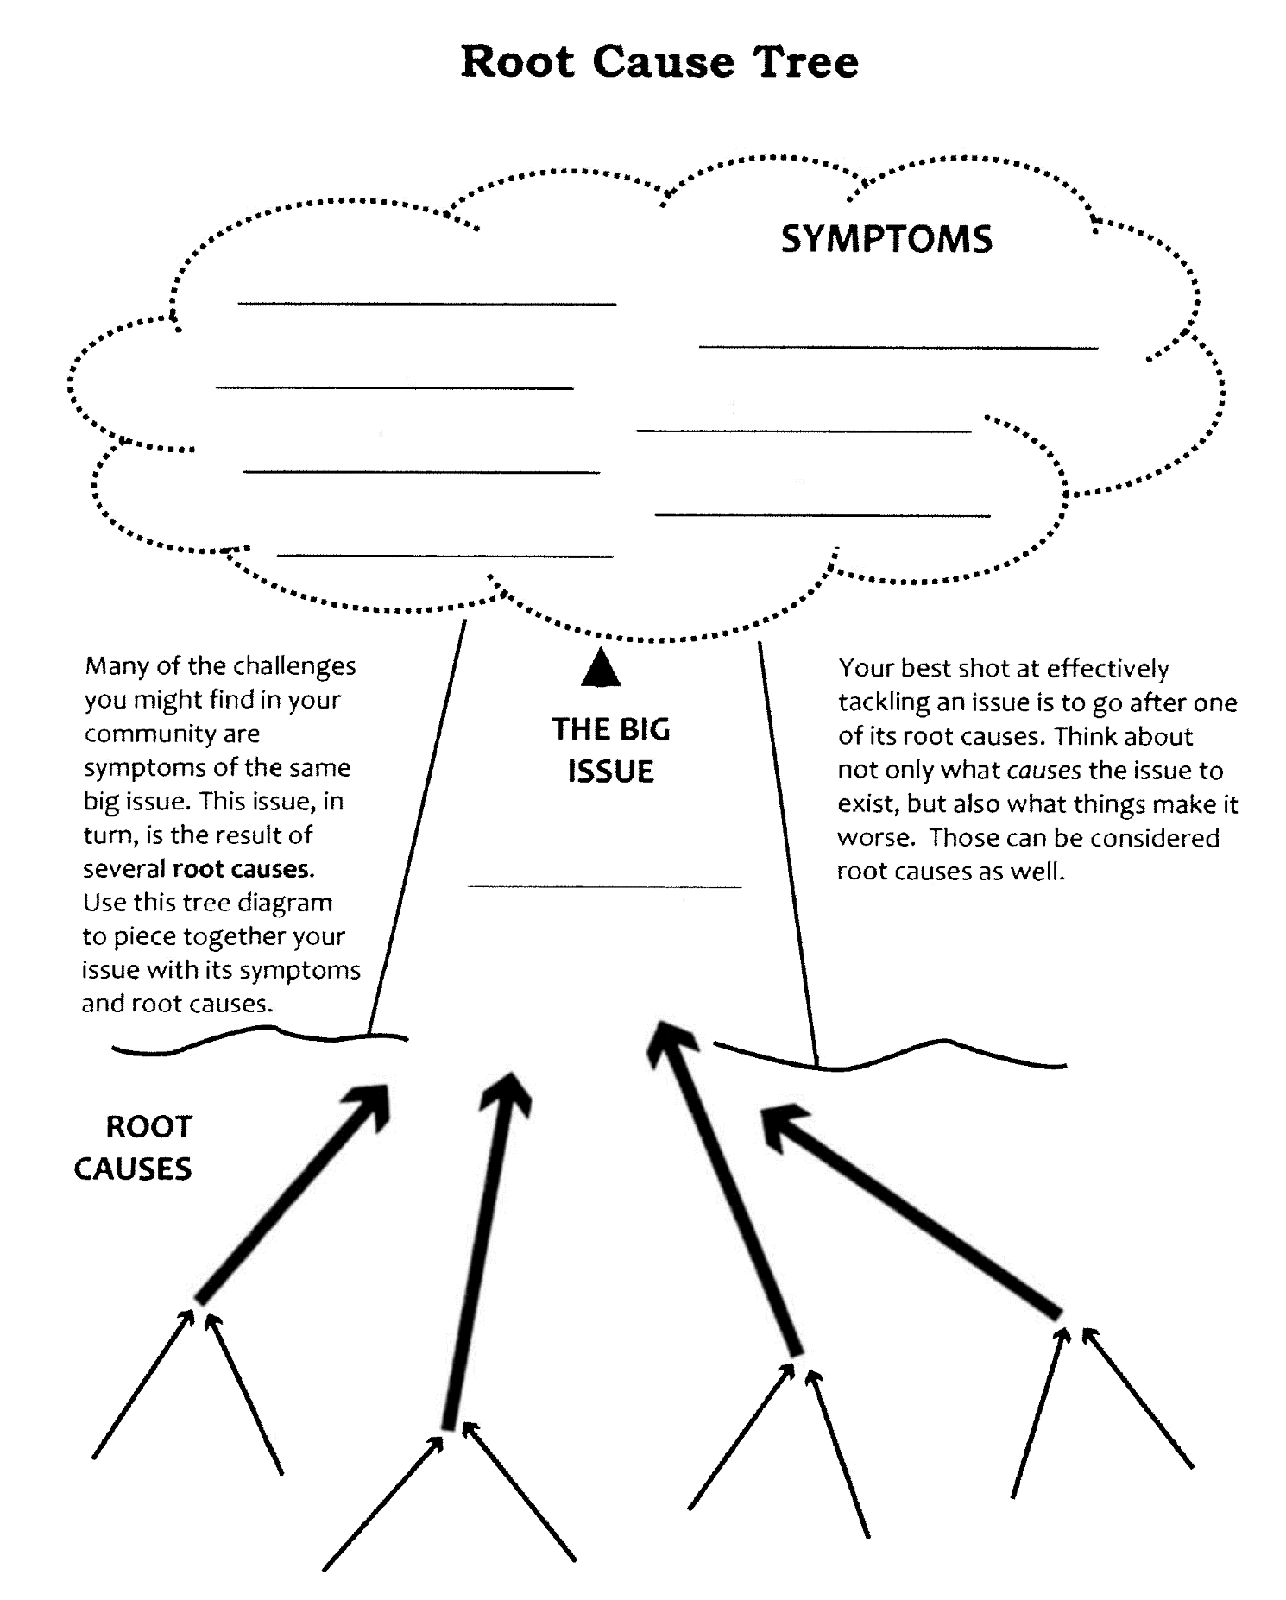

Generating solutions
It would be nice when faced with a problem to be able to immediately have the perfect solution pop into your head. Unfortunately, it's not always quite that easy. Even with a group of intelligent and dedicated people, it's not always easy to think of any solution to the problems facing the community, much less one that is effective and feasible. Just like anything else, it takes work - some hard thinking, evaluating, and decision-making on the part of all members. Listed below are just a few of the many different ways to do some thinking:

- Simply go around the room and ask everyone to suggest ideas.
- Send a piece of paper around the room. People can write down their ideas, which can later be discussed without anyone knowing who suggested which idea.
- Idea writing. Idea writing is especially helpful to people who like to write. It also helps many people generate and comment on ideas in a short amount of time. Large groups should be divided into small groups of five or six. Each person writes a possible solution to the problem on his/her own pad of paper. Then each person puts their pad on a table in the middle of the group. Next, everyone takes someone else's pad and comments on the idea. People keep doing this until everyone in the group has commented on everyone else's idea. During or after the meeting, all the ideas are discussed or summarized in a report.
- Brainstorming. Brainstorming is a tried-and-true way to come up with ideas in a group. The method is simple: The problem is stated, and the recorder stands in front of a room with some paper or a blackboard. People in the group say whatever ideas pop into their minds. The recorder writes down all of the comments made.

Helpful hints to keep in mind when brainstorming include:
- Watch out for assumptions; every unnecessary assumption reduces the number of potential solutions.
- Simply giving instructions that people can or should be creative in the brainstorming session may help raise the number and quality of solutions created.
- No idea is too outlandish. The meeting recorder writes all the ideas down. Why? An idea that seems ridiculous on first hearing might turn out to be possible and even desirable. It may also be modified by other members of the group, and end up being the perfect solution to the problem.

When brainstorming keep these points in mind:
- Nobody should comment on how good or bad the ideas are; there should be no discussion about them at this time. Keep producing all kinds of ideas until everyone runs out of steam.
- Ideas can be "piggy-backed" or combined as people see connections during the process.
- The facilitator should keep the energy high and constantly ask for more and different ideas. This may even be done in the manner of an auctioneer, with constant chatter and a fast-paced discussion.
- If the group gets off the subject, the facilitator or recorder should gently remind them of why they are there.
- Discussion, analysis, and idea selection come later.

Evaluating solutions
Hopefully your work up to this point has produced many potential solutions. Now, it's time to decide which idea is best. There are many possible ways to do this. One approach includes doing the following three things for each idea:
- Judge each idea independently. List on separate pieces of paper:
  - What you like about the idea
  - What you don't like about the idea
  - What the side effects might be
- Ask the following questions:
  - Is it practical?
  - Is it effective?
  - Is it cost effective?
  - Will it be easy to put into practice? There's a lot involved in this question. Related questions might include: Can it be done by group members, or will you need outside help? How much time will it take? Will anyone need to learn new skills?
  - Will it be accepted by everyone involved? That is, by group members, those who will be affected, and those doing (and paying for) the work? How about the community as a whole?
  - Is it consistent with other things done by the group?

